CREATE NEW TYPESCRIPT CUCUMBER PROJECT

1. initialize npm
   1. Create new folder
   2. cmd > npm init -y 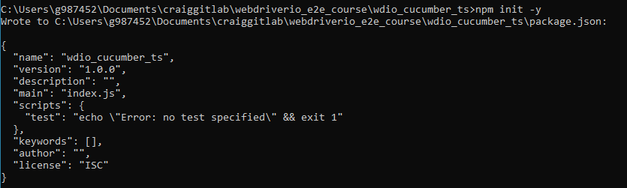
2. initialize new webdriverIO project
   1. If behind firewall (ssl and proxy):
      1. > npm config set strict-ssl false
      2. > npm config rm proxy
      3. > npm config rm https-prox
      4. > npm i chromedriver --ignore-scripts (This will not install chrome.exe need manual copy 🡪 see below troubleshooting)
   2. npm init wdio
   3. will install min packages and then run WDIO CLO wizard:
   4. if accept default value can get to generate some tests to check installations 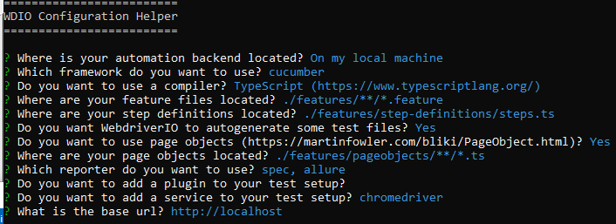
   5. To start the test, run: > npm run wdio

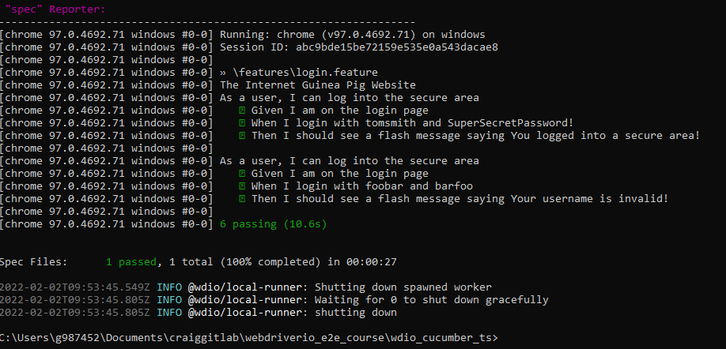

* 1. exit cmd

TROUBLESHOOT: could not find chromedriver.exe in default path ../chromedriver.exe

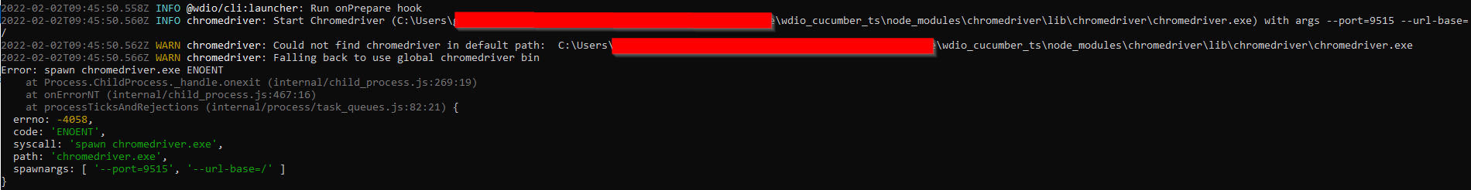

Have to copy chromedriver.exe manually as download has been blocked.

TROUBLESHOOT: Failed to create session



Session is not being created successfully using integrate terminal (Powershell or CMD). Works ok with external cmdline and git bash terminal

THIS DOES NOT ALLOW EXECUTION – all terminals opened by VSCode fail to create session. Need to open via File Explorer

File 🡪 Preferences 🡪 Settings 🡪 Terminal 🡪 Explorer Kind can change to external to give option to launch external on right click instead of internal. (For workspace only or for user as required)

**Enable typescript:**

<https://webdriver.io/docs/typescript/>

update tsconfig.ts

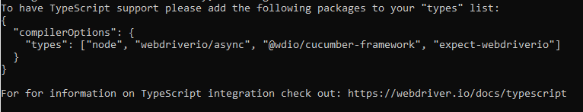

1. Check that your tsconfig.json

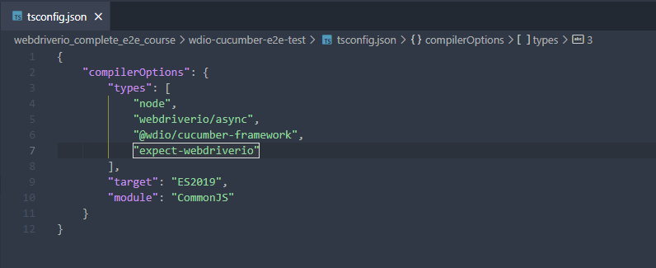

When using > npm run wdio

It is picking up the wdio under scripts in the package.json which will run the cmd there, as default

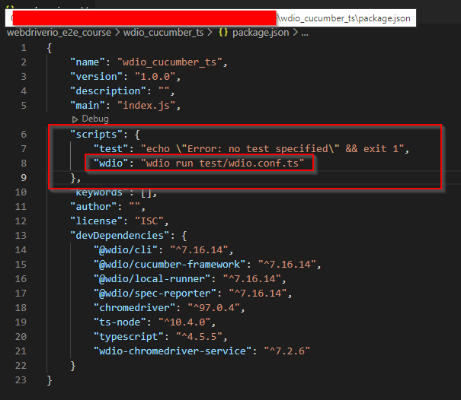

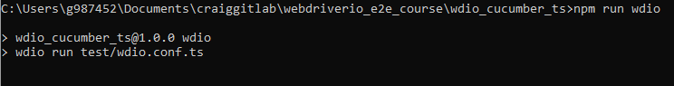

Let us keep the conf files in the root:

1. Move the tsconfig.ts & wdio.conf.ts to the root
2. Update package.json 🡪 scripts – “wdio: run ./wdio.conf.ts”
3. Update wdio.config.ts path to new tsconfig.json location 🡪 “./tsconfig.json

Also move features folder under test

1. Update references in the wdio.conf.ts
   1. specs : [ 🡪 
   2. Also update to steps.ts to *.ts cucumberOpts: { 🡪 

Add allure reporter - if forgot when setting up project 😊

Update wdio.conf.ts 🡪

    reporters: ['spec', ['allure', {

        outputDir: 'allure-results',

        disableWebdriverStepsReporting: false,

        disableWebdriverScreenshotsReporting: false,

    }]],

The following VSCode extensions are recommended (e2e course)

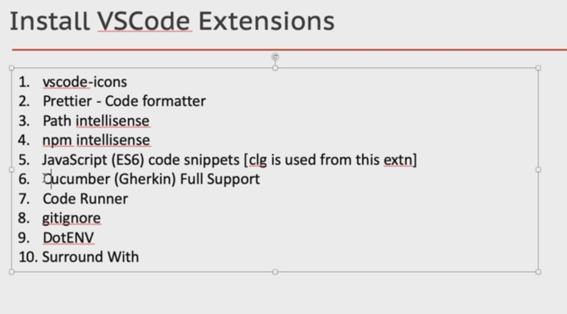

Vscode-icons

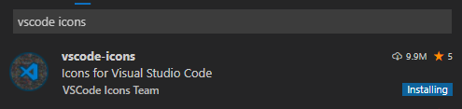

Prettier Code formatter

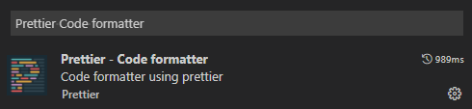

Path intellisense

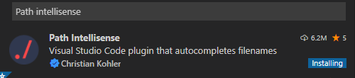

npm intellisense

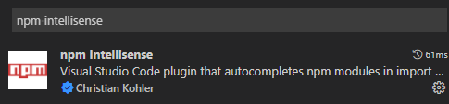

JavaScript (ES6) cide snippets

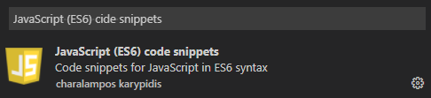

Cucumber (Gherkin) Full Support

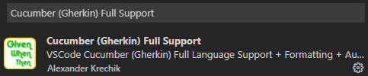

Code Runner

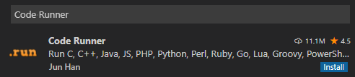

gitignore

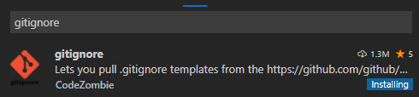

DotENV

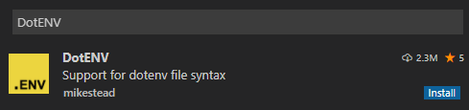

Surround With replaced with Surround (See dl’s and votes)

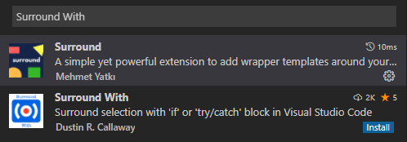

When install packages for typescript should also install the type declaration file or create on for example Chai

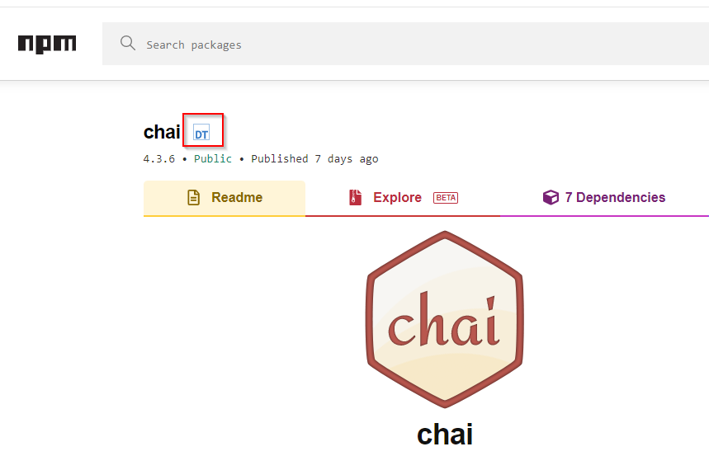

The ‘DT” is the type definitions for chai, this will make them available (autocomplete)

Click on “DT” link and see install cmd > npm install –save @types/chai

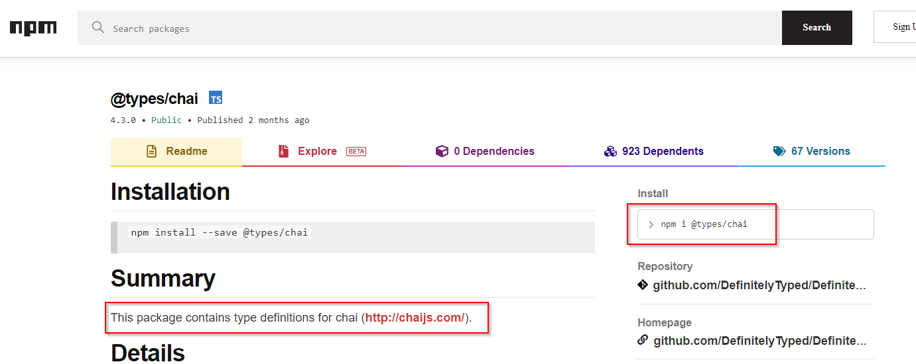

Extract from Course:

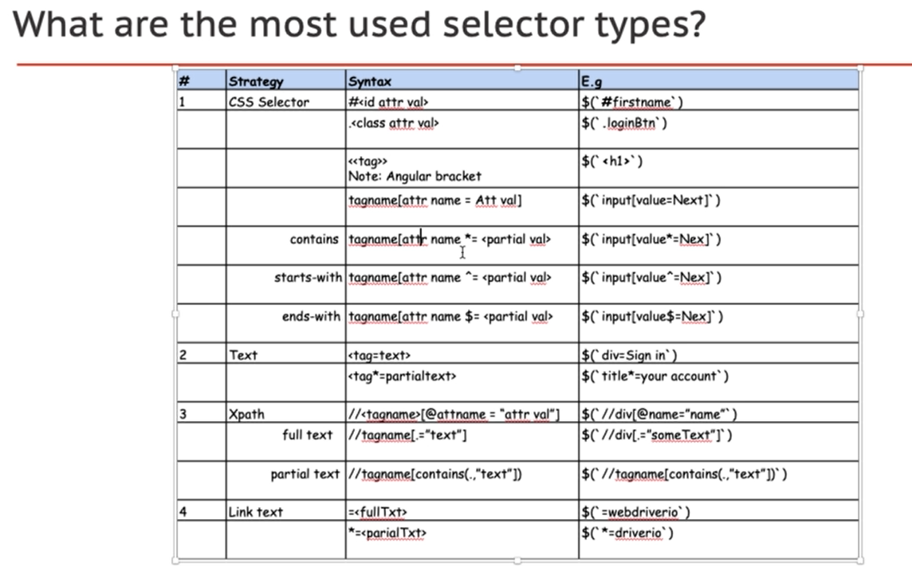

Demo web page: open-source-demo/orangehrmlive.com/

<https://opensource-demo.orangehrmlive.com/>

in chrome can pause javascript to get elements before they disappear. 🡪

source 🡪 F8 will go to debug js mode

a dynamic location can be constructed using template literal or string concatenation

eg:

$(`a=Welcome ${username}`) where ` is the back dash (tilde button) and the username will be used ar runtime

Demo pages

<https://the-internet.herokuapp.com/>